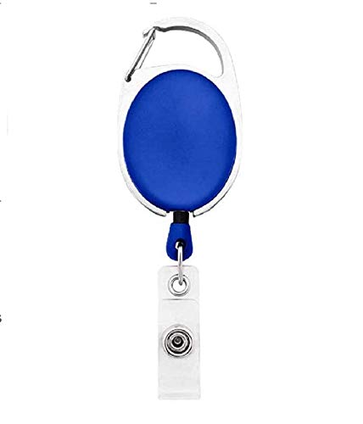



Marie Burgess | 
Marketing
03/02/2022
O +ve
12345678

Questions / Queries – Drop an email to mailmukeshkala@gmail.com

